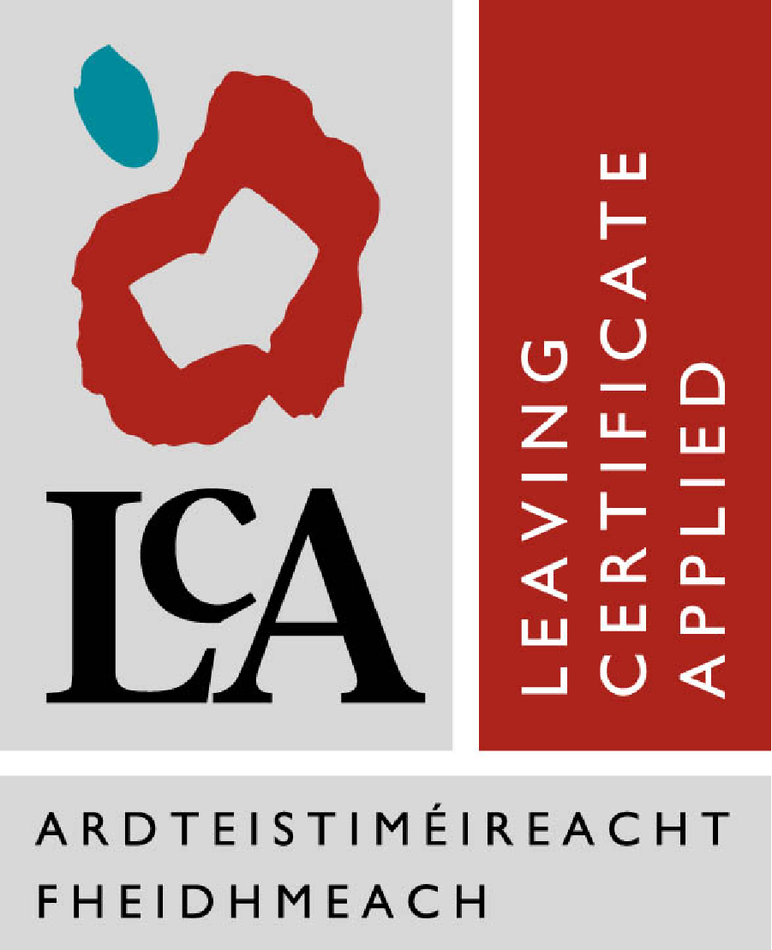
Leaving Cert Applied Admissions Policy

Leaving Certificate Applied is a course that is specifically designed for students for whom the
traditional, Leaving Certificate Established nor the Leaving Certificate Vocational Programme are suitable. This aims of this programme differ radically from those of the Leaving Certificate Established and Leaving Certificate Vocational Programmes, and indeed this is reflected in the delivery and assessment of the Leaving Certificate Applied programme.

In an attempt to ensure the suitability of the course for students and the suitability of students for the course, a selection process has been established. Our selection procedure includes an
application form, credit awarded for good discipline/attitude, and an interview for each potential student. Marks will be awarded on the following basis:
Application form- /10
Discipline- /30
Attendance - /30
Interview - /30
Total- /100

Every effort will be made to offer a place on the Leaving Certificate Applied course, to students who achieve 60% overall in the selection procedure. Those students who are not successful will be offered a place on the Leaving Certificate Established course.

This Leaving Certificate Applied Admissions’ Policy forms part of the school’s overall
Admissions’ policy.

Procedure for Application
- The LCA Coordinator will give information on the Leaving Cert Applied programme to parents/guardians at Information Evening.
- Then the LCA Coordinator visits all Transition Year and 3rd year groups to give an information presentation on the LCA programme. Students are given information leaflets on the programme and application forms.
- Completed Application Forms (See Appendix) must be returned to the LCA. Co-Ordinator by the Closing Date specified. (Late applications may not be considered.) Acceptance of the completed application form does not confirm or imply an expectation of being offered a place on the programme.
- External Applicants may fill in the Enrolment Form for St. Dominic’s College and following an expression of interest in the LCA. Programme, may request and complete an LCA Application Form and are then subject to the same admission procedures as internal applicants.
- The LCA Co-Ordinator will consult members of the Teaching Staff with respect to the LCA Application List.
- An LCA. Selection Committee will be established annually comprising L.C.A. Co-Ordinator, Year Head (3rdYr and or TY), Guidance Counsellor, Deputy Principal, Principal.
- Applicants will be interviewed.
The following criteria will help ascertain suitability for the Programme:
- Level of interest displayed by the student on the application form
- Level of interest indicated by the candidate at the interview.
- Willingness to participate fully in all elements of the L.C.A. Programme.
- Student’s satisfactory attendance record in school.
- Student’s record of adherence to the Code of Behaviour of St. Dominic’s College or in the case of an external candidate, the student’s previous school.
- An assessment of the student’s competence and value to be derived from participation in key elements of the L.C.A. programme.
- Assessment of the contribution the applicant can make to the L.C.A. Programme.
- The applicant’s age and/or pastoral care needs as communicated by the Year Head, Guidance Counsellor and/or other professionals in the school.

Following final selection by the Selection Committee, successful candidates will be offered a Provisional Place on the Programme and their Parents/Guardians will be informed by letter.
A review of students’ suitability will be reviewed on a monthly basis over the two years. Should it be deemed that students are not suitable for the programme or the programme is not suitable for the students, they will be advised to transfer to 5th/TY.

NOTE: Parents/Guardians may appeal the decision of the Selection Committee to the Board of Management.

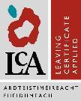 | St Dominic’s College
Application for Admission to Leaving Certificate Applied

To be completed & signed by the student and signed by parents/guardians

STUDENT’S PERSONAL DETAILS
Name: _______________________________
Class ________________________________

Please rate yourself under the following headings:
 | Very Good | Good | Not Good
Attendance
Punctuality
Ability to follow instructions
Ability to take correction
Completion of homework

What do you like about school at the moment? _____________________________________________________________________________________________________________________________________________________________________________________________________________________

What is your favourite subject? (Explain why)
______________________________________________________________________________________________________________________________________________

What do you hope to do when you leave school? ______________________________________________________________________________________________________________________________________________

Why do you want to enter the programme? ____________________________________________________________________________________________________________________________________________________________________________________________________________________________________________________________________________________________
Outline two reasons why the school should allow you entry to Leaving Certificate Applied
___________________________________________________________________________________________________________________________________________________________________________________________________________________________________________________________________________________________________________________________________________________________________

Are you prepared to do the following:
• Have 90% attendance for each subject module: Yes ... No …
• Complete four Key Assignments
(minimum) for each module: Yes ... No …
• Complete seven "Tasks": Yes... No…
• Meet all deadlines for Key Assignments
and Tasks as set by individual teachers and
the Department of Education: Yes... No…
• Behave excellently always in school and for
all out of school activities: Yes ... No …
• Complete all homework on time: Yes... No…
• Wear the full school uniform every day: Yes ... No …
• Bring all necessary equipment, books, resource materials
(e.g. ingredients for Hotel Catering and Tourism)
to class every day. Yes ... No …
• Co-operate with your classmates in the use of
shared facilities (e.g. tools or stationery): Yes ... No …
• Take full responsibility for arriving to school
on time and likewise to every class on time: Yes ... No …
• Be co-operative, courteous, friendly and adult-like
in your relationships with your teachers and fellow
classmates: Yes ... No ..

