Mandatory Template 3: Notification regarding the Board of Management’s review of the Child Safeguarding Statement

To: The School Community

The Board of Management of St. Dominic’s College wishes to inform you that:

• The Board of Management’s annual review of the school’s Child Safeguarding Statement was completed at the Board meeting of 17 February 2022

• This review was conducted in accordance with the “Checklist for Review of the Child Safeguarding Statement” published on the Department’s ‘website www.education.ie
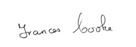

Signed _____________________________________ Date 7 March 2022

Chairperson, Board of Management
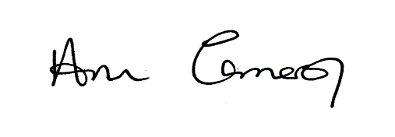

Signed _____________________________________ Date 7 March 2022

Principal/Secretary to the Board of Management

