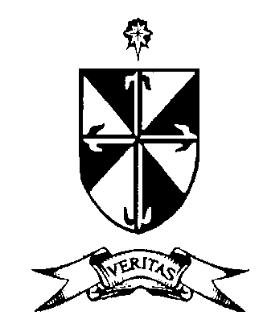
ST. DOMINIC’S COLLEGE
CABRA, DUBLIN 7
TEL: 01-8385282 / 8387218 / 8823994 FAX: 01-8683003
E-mail: info@stdominics.ie Website: www.stdominics.ie 60731F

Student Calendar 2021-2022 (Updated on 4th November 2021)

Date | Day | Event
3rd September 2021 | Friday | First full day of teaching
10th/11th Sept 2021 | Thursday/Friday | TY Carlingford trip for TY students
17th Sept 2021 | Friday | 6th year Geography Field trip
20th Sept 2021 | Monday | Junior Cycle Cluster Day-No school for students
22nd September 2021 | Wednesday | Hospice Coffee Morning for 1st years
29th September 2021 | Wednesday | 5th year Team Building Day  To Causey Farm.
4th October 2021 | Monday | Occasional school holiday
Date to be confirmed | Monday-Friday | Math’s week
11th October 2021 | Monday | CAO/HEAR/DARE Talk by Zoom 7pm
18th Oct 2021 | Monday | 6th year PTM
25^{th-}29th Oct 21 | Monday-Friday | Midterm Break
1st Nov 2021 | Monday | Return to school
2nd Nov 2021 | Tuesday | 3rd year PTM
Date to be confirmed | Monday-Friday | Science Week
15th-19th Nov 2021 | Monday-Friday | TY Community Care Week
15th-19th Nov 2021 | Monday-Friday | Stand Up! Week
22nd-26th Nov 2021 | Monday-Friday | College Awareness Week
1st Dec 2021 | Wednesday | 2nd year PTM
6th Dec 2021 | Monday | Occasional school holiday
15th-22nd Dec 2021 | Wednesday-Wednesday | Christmas Class Exams for 1st, 2nd, 5th years.  Class as normal for 3rd and 6th years
23rd Dec 2021 -Jan 5th 2022 | Thursday-Wednesday | Christmas holidays
Term 2
6th January 2022 | Thursday | Return to school
24th January 2022 | Monday | 5th year PTM
30th Jan-Feb 5th 2022 | Sunday-Saturday | Catholic Schools Week
31st January 2022 | Monday | Information evening for 3rd year parents
7th-18th February 2022 | Monday-Friday (2 weeks) | TY Work experience
7th-11th Feb 2022 | Monday-Friday | Mock Examinations week 1
14th-18th Feb 2022 | Monday-Friday | Mock Examinations week 2
21st-25th Feb 2022 | Monday-Friday | Midterm break
28th February 2022 | Monday | Return to school
7th March 2022 | Monday | Junior Cycle Cluster day. No school for students
8th March 2022 | Tuesday | 1st year PTM
1-4th March 2022 | Monday-Thursday | Literacy week
14th, 15th, 16th March 2022 | Monday/Tuesday/  Wednesday | Seachtain na Gaeilge
17th March 2022 | Thursday | St Patrick’s Day
18th March 2022 | Friday | Occasional School holiday
22nd March 2022 | Tuesday | Information evening for incoming 1st year parents
11th-15th April 2022 | Monday-Friday | Easter holidays week 1
18th- 22nd April 2022 | Monday-Friday | Easter holidays week 2
Term 3
25th April 2022 | Monday | Return to school
Date to be confirmed | Mon-Fri | Orals and Practicals week 1
Date to be confirmed | Mon-Fri | Orals and Practicals week 2
Date to be confirmed | Friday | Wexford Heritage Centre trip for 1st years
2nd May 2022 | Monday | Bank holiday
5th May 2022 | Thursday | Health Fest Day (TBC)
20th May 2022 | Friday | 6th year Graduation
26th May 2022 | Thursday | TY Graduation
30th May-3rd June 2022 | Monday-Friday | House exams for 1st, 2nd, TY and 5th years
8th June 2022 | Wednesday | State Examinations

