Information Sheet

Dear Parents,

Uniforms are now in stock and can be purchased in our Shop or
Online at www.grantsuniforms.ie either for home delivery or
Click & Collect (Not available in August)

Uniform items purchased early in the Summer can be exchanged at the shop right up until the students go Back to School. As usual Uniform items must be as they left the shop with all labels attached. Please remember to bring your receipt

Parents preferring to come to the shop,
We are open for business.
9.30am- 5.30 pm Monday to Friday
9.30 – 5pm on Saturday
We do not close for lunch.

We are closed on Sundays and Bank Holidays.

PARKING
On-street Pay and Display or Smithfield Multi-storey Car Park
348 spaces 5 mins walk away
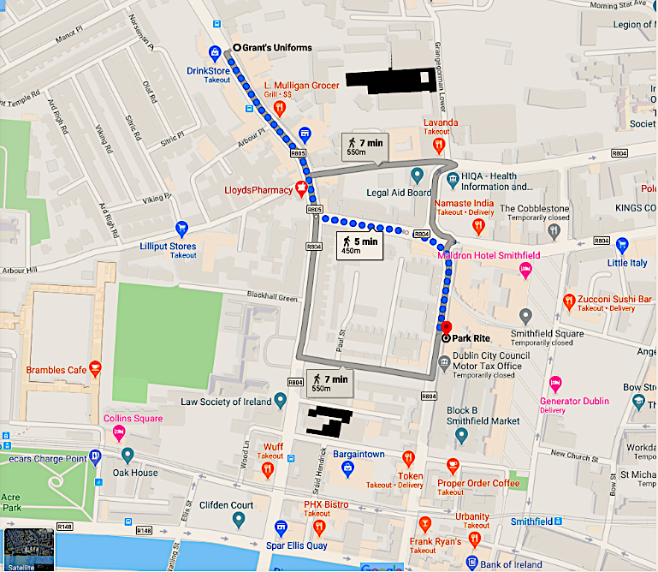

Thank you for your support, the end is in sight. Stay safe and well.

Jim & Karen

