1819 - 2019
Celebrating 200 years of Dominican Presence in Cabra

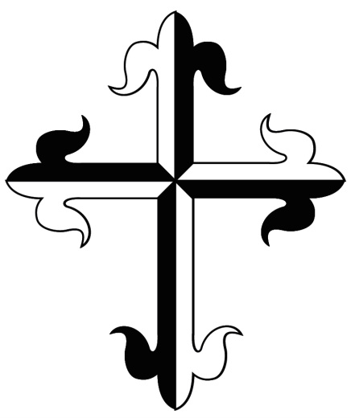
A sincere thank you to all composers who supported us by submitting entries to our Choral Composing Competition. We were delighted to receive such high quality music from all across the world. We
wish you all every success and enjoyment in your future work.

It now gives us great pleasure to announce the winning songs and their composers in each of the categories. In both categories, the songs were selected unanimously by the adjudicators. Congratulations to our two prize-winning composers and many thanks again to all who took part.

Category A: Established composers with previous experience of writing choral arrangements.
Winning entry: "We are Called to Praise" composed by Mr. Padraig Meredith
Category B: New and emerging composers who have not yet had material performed publicly by a choral group. This section of the competition is open to present and past pupils of Dominican Schools only.
Winning entry: "By My Life" composed by Ms. Nuala Murray

A short introduction to the winning composers:

Mr. Padraig Meredith:
Pádraig Meredith is a composer from Newbridge in County Kildare. He studied Music, Education, and Wellbeing at various universities including UCD, the University of Limerick, Queens University Belfast, and WIT. He works as a Music and SPHE teacher at the Holy Family Community School, Rathcoole. He composed the theme song for the Dublin Diocesan ‘Year of Evangelisation’, and continues to compose liturgical music from mass settings to choral hymns. He composed the score for the Irish dance and musical theatre work “The Cloak” based on the life of Saint Brigid

Ms. Nuala Murray:
Nuala Murray is a past-pupil of St. Dominic’s High School, Falls Road, Belfast and now lives in Co Down. She enjoys a fulfilling career as a music therapist working with adults with mental health difficulties and a teacher of singing. She also directs a community choir and currently holds the position of director of music at St Patrick’s church, Donegall Street, Belfast.

