St. Dominic’s College, Cabra
TY
WORK EXPERIENCE PACK
2019-2020

ALL YOU NEED TO KNOW GUIDE ………………..

KEY POINTS TO NOTE:
- Indemnity Insurance Letter to cover Students Work Experience Placement(s). This letter will be updated on Nov 1st 2019. Please use letter below until this is updated.

- TY Community Care Form A Week: 11th Nov – 15th Nov 2019

- TY Work Experience Form B Week 1: 3rd Feb – 7th Feb 2020

- TY Work Experience Form C Week 2: 10th Feb – 14th Feb 2020

- TY Extra Work Experience Form B
Remember all Extra Work Experience must be checked and approved first with TY Co-ordinator, Ms Branigan, by writing in the form of letter and leaving letter on Ms Branigan’s desk or email to: gbranigan@stdominics.ie
Please Note: Not all Extra Work Experience offers may be sanctioned. Consideration is given to TY Programmes and Courses.

- National Vetting Bureaux (Garda Vetting – Child protection issues):
    - Vetting Information (Form NVB1)
    - Parents/Guardian Consent Form (NVB3)
    - ID Validation Form

The very best of luck to all of you during your work experience(s) throughout this academic year. Remember, it’s about taking up all OPPORTUNITIES and seizing the moment!

_________________________________
Ms Branigan: TY Co-ordinator, St. Dominic’s College, Cabra.

GARDA VETTING GUIDELINES FOR TY STUDENTS
When you the TY Student(s) are considering a work placement with children or vulnerable adults you will be requested by your employer to be Garda Vetted.
Students who are over 16 years of age will be Garda Vetted with parental consent.
Any student who is under 16 years of age at the date of work experience cannot be Garda Vetted. This may limit your options for work placement. Please confirm this requirement with the proposed employer.
Please note that Garda Vetting is a lengthy process and may take several weeks/months to be processed. So its very important that if you know that your require Garda Vetting, that you complete the following documents with urgency:
Form NVB 1 - Vetting Invitation
NB Please note that it’s a Parent Email Address that is required in Form NVB 1.
Form NVB 3 - Parent/Guardian Consent Form

ID Validation Form - Valid Identification Documents
NB Please ensure that you (Student) supply identification in compliance with the requirements as outlined in the ID Validation Form
Please complete the above documents with immense care to ensure accuracy and this will reduce delays in the processing of Garda Vetting.
Thanking you.
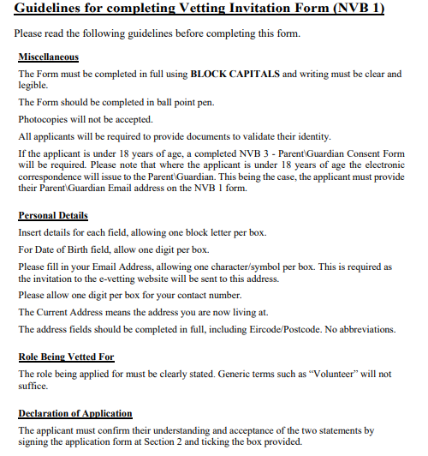

NVB 1

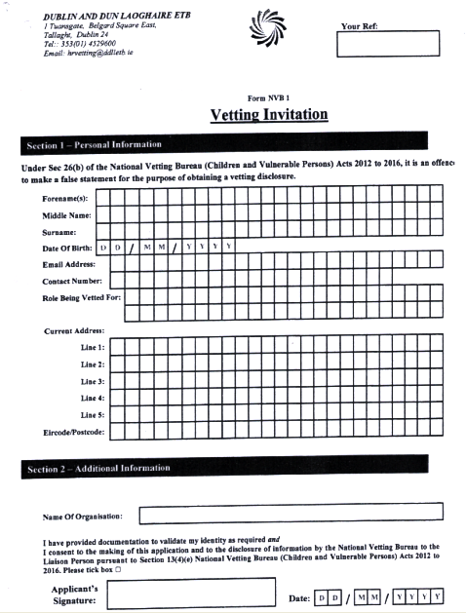
Note: Please return this form to the Transition Year Co-ordinator at in St. Dominic’s College for checking and in due course will be submitted to Human Resource, Head Office for Processing. An invitation to the e-vetting website will then be sent to your Email address.

NVB 3
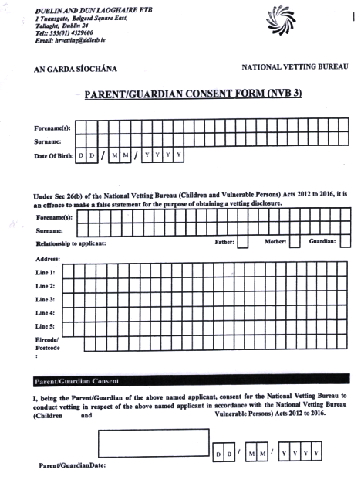
ID VALIDATION FORM
